Wireframe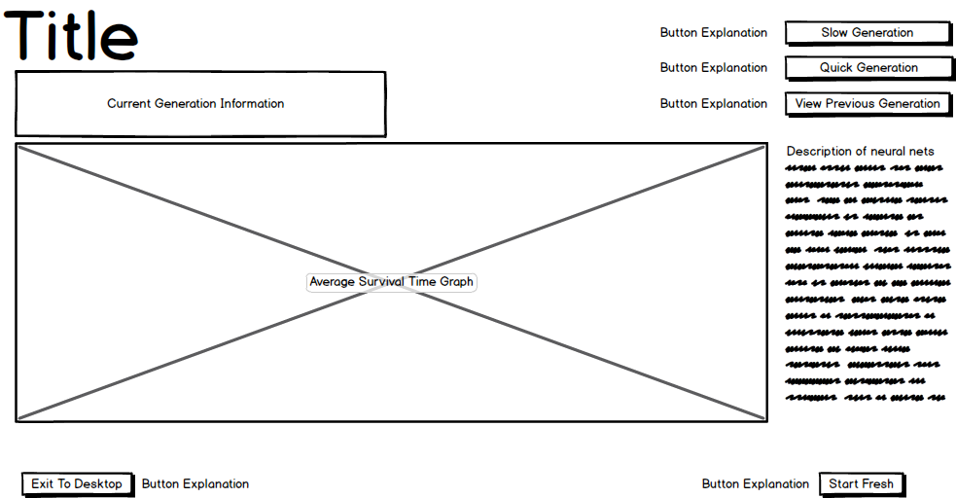

Low-fidelity Design

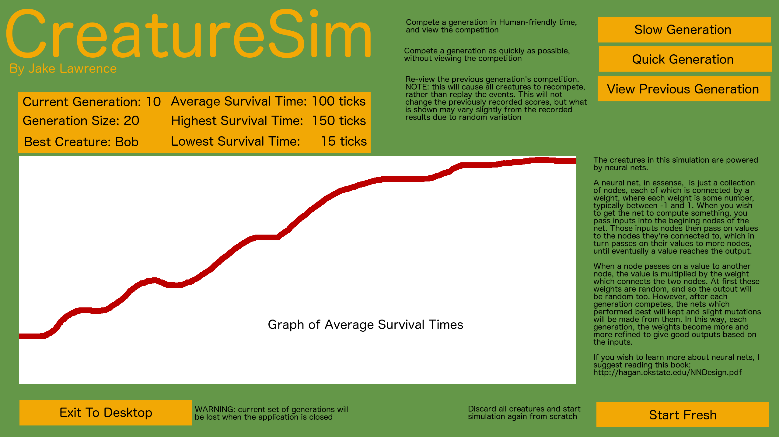

Colour Scheme

Organic colour scheme due to theme of creatures

Graph Colour

#FFFFFF

Stands out against background colour

Text Colour

#000000

Stands out against both background and button colour

Background Colour

#649748

Compliments button colour

Button Colour

#ED6D0D

Compliments background colour

Start Fresh Button

Triggers functional requirement 2

Exit to Desktop Button

Terminates the application

Best Creature’s Name

Requires functional requirement 8

Graph of Average Survival Times

Partially fulfils functionality requirement 6

Information Panel

Partially fulfils functional requirement 6

Title

Button Explanation Text

Helps to satisfy user requirement 1

Explanation text

Satisfies user requirement 3

View Previous Button

Triggers functionality requirement 5, but with the previous generation

Quick Generation Button

Triggers functionality requirement 4

Slow Generation Button

Triggers functionality requirement 5